Visualization Project

Milestone 1(Concept & Prototype)

Group Members: Temirlan Ulugbek Uluu, Zhao Liu

Target Application:

An easy to use and straight forward visualization of leading cause of death throughout years considering demographics and age.

**Dataset** we use:

Dataset1:

Leading Causes of Death, United States,

Containing data about leading cause of death count within different states and average age range from year 1999-2015

Source: National Center for Health Statistics

https://www.cdc.gov/nchs/fastats/leading-causes-of-death.html

Dataset2:

Death rates and life expectancy at birth, United States,

Source: National Center for Health Statistics

<https://data.cdc.gov/NCHS/NCHS-Death-rates-and-life-expectancy-at-birth/w9j2-ggv5>

**User goals:**

This will be an easy to use and straight forward visualization of leading cause of death throughout years considering demographics and age. Users can easily adjust different filters to view and analysis the trend of specific cause of death in different ages, races, regions etc. News for example can analysis the trend with certain policy or incident that may or may not take into effect. American cancer association for example can review the trend of death caused by cancer to give more strict diet suggestions or raise fund from public. Policy makers for examples can take this into account for adjusting their public health insurance plan or makes more strict policy on food industries.

Design Choices:

**Wireshark graph:**

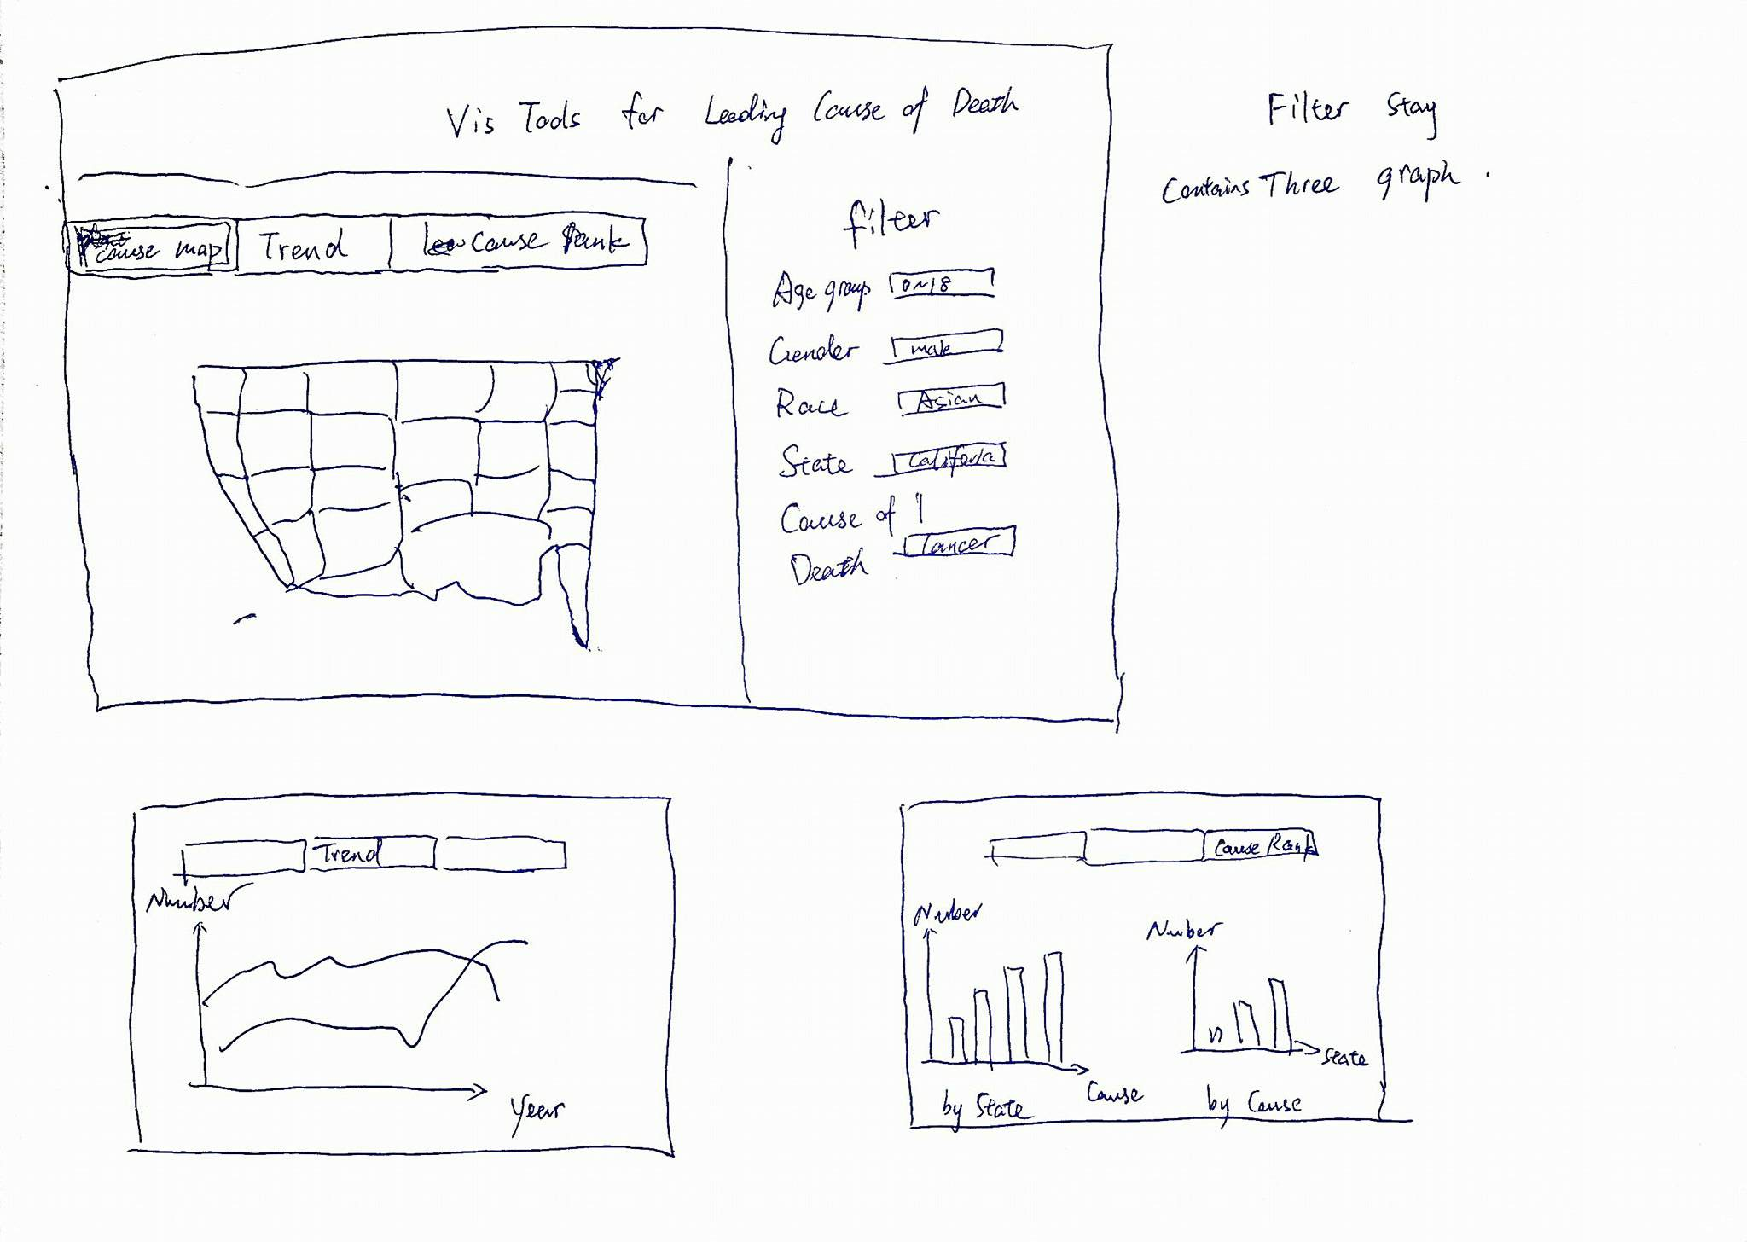

**Design choices justify:**

We first want to use a dynamic geographic heatmap to visually give user a straight forward impression of leading causes of death throughout the past 20 years. We use different color and depth to indicating each in different cause of death and death count.

Second we want to use a multi-line chart to give user a direct impression of the growing or decreasing trend throughout those years. By using different lines user can easily compare different causes of death experience different trend in years.

Finally we decided to use two bar charts to rank most cause of death and highest death rate state to give user a direct impression of which causes or states are the most severe ones.

**We have implemented:**

Basic skeleton of website;

Second and third ideas of charts;

**To Do:**

First idea of charts;

Refine filters and 2,3 charts;

Beautification of HTML+CSS

**Implementation Details:** We choose to use HTML+CSS+d3.js to implement charts, because d3.js has great flexibility for creating the specific charts we wanted and works seamlessly with existing web technologies. And We plan to use python+Django+AmazonAWS to deploy our project on internet.

**Work Distribution(Milestone 1):**

Temirlan: Set up HTML skeleton; line chart implementation in d3.js;

Zhao: bar chart implementation in d3.js; Reports